Teens Spend Wild Spring Break In D.C. Begging Lawmakers For Their Lives
The Onion 3/27/18 12:50pm

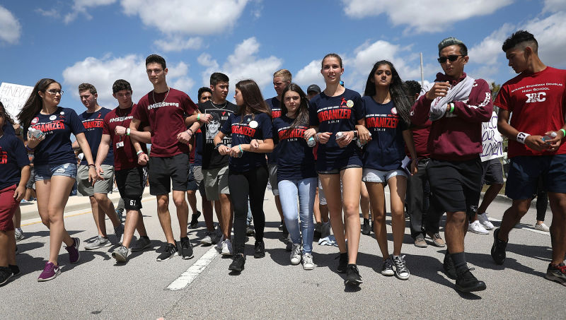

WASHINGTON—Cheering, yelling, and generally running rampant through the nation’s capital, a group of teens were reportedly spending a wild spring break in Washington, D.C. Tuesday begging lawmakers for their lives. “These kids are all over the place, showing no restraint whatsoever while pleading with their representatives to stop the killing,” said onlooker James McCormick, 40, who described watching hundreds of high school students pouring into the streets and holding loud, raucous protests for hours at a time demanding legislators take action to prevent the slaughter of their classmates. “There must be hundreds of them making a spectacle of themselves and completely disrupting normal D.C. life with their incessant entreaties against being murdered by weapons of war. I don’t think they’ve let up on holding their elected officials accountable for their records on gun control once since the weekend. Where do they get all this energy from?” At press time, McCormick conceded that these teenagers may as well go nuts now, since it would only be a few years before they started to mellow out about the potential of getting shot at any time they’re out in public.
https://www.theonion.com/teens-spend-wild-spring-break-in-d-c-begging-lawmakers-1824115876

